

**IMAGINE CUP 2012**

**KINECT FUN LABS CHALLENGE  
ROUND 1 PROJECT PLAN**

**Kinect Fun Labs Challenge Project Plan for Kinasion**

*Instructions*

*This is the Kinect Fun Labs Challenge Round 1 Project Plan Template. This is your Team’s Round 1 Entry Requirement. It is designed to guide you to include the required components of your Team’s project. Please use the questions in each section to align your submission with the judging requirements. Steps:*

1. *Insert your team name above*
2. *Answer the questions below. Please be thorough.*
3. *This Application Summary must not exceed 15,000 characters including spaces.*
4. *The character count starts below the line identified* *here**\*.*
5. *This document must be submitted in the English Language.*
6. *This document must be named as follows: Kinect_Fun_Labs_Challenge_Round_1_Project_Plan_[Team Name]. DOC, .DOCX or .PDF, .RTF or .TXT.*

Submit your Team’s Round 1 entry by utilizing the submission form on the entry panel of the [Kinect Fun Labs Challenge page at imaginecup.com](http://imaginecup.com/Competition/mycompetitionportal.aspx?competitionId=68) no later than then closing date of Round 1 (*6 March, 2012,**11:59 GMT).*

*Questions*

1. What problem are you solving as it relates to the [Imagine Cup Theme](http://www.imaginecup.com/../AppData/Local/Microsoft/Windows/Temporary%20Internet%20Files/AppData/Local/Microsoft/Windows/Temporary%20Internet%20Files/Content.Outlook/AppData/Local/Microsoft/Windows/Temporary%20Internet%20Files/AppData/Local/Microsoft/Windows/Temporary%20Internet%20Files/Content.IE5/AppData/Local/Microsoft/Windows/AppData/Local/Microsoft/Windows/Temporary%20Internet%20Files/Content.Outlook/N9KG28AD/TBD%20URL)?

Describe the real world problem you are working to solve (not the application itself – that information goes below). Who will benefit from having this problem solved? How will they benefit? Will your solution impact a large number of people very broadly, or a smaller number of people very deeply?

*2. Name and Description of your Application:*

What is the name of your Application or Creation? Describe your Application in detail.

*3. Originality & Innovation:*

How unique and original is your idea? Is the technology itself new and innovative, or is it the application of existing NUI technology that is compelling? Were you inspired by an existing application of the Kinect?

4. Pre-existing source code:

If pre-existing source code files or third-party binary libraries are to be incorporated into the Application or Creation (such as physics and game engines or control toolkits), then this pre-existing source code must be clearly identified below and must not infringe on any third party rights, and must be used in accordance with all applicable licensing and use terms. This includes images, music and source code. Tell us what open source you are using, who owns it and what the applicable license information is.

5. Unique NUI Features:

Describe the Natural User Interface (NUI) features of your application. You must use features that are readily available in any version of the official Microsoft Kinect for Windows SDK. At this time, you should have a good idea of any supporting back-end infrastructure or cloud resources that your application requires. If your application uses any cloud-based or other remote services, please describe the back-end infrastructure in detail. Submissions that demonstrate technical innovation beyond these baseline features will be highly regarded.

*6. Usability:*

user interface applications need to be as intuitive as possible. Is the application easy to use, or does it require extensive training or trial-and-error? Does the application provide hints or other indicators to show the user how to interact?

*7. Presentation & Polish:*

If you were to make a video about your project, what key points would you highlight? What scenarios would you show the viewer to clarify the purpose and impact of your project?

*Character count starts below this line. Please remember that any application summary that includes more than 15,000 characters, including spaces, will be disqualified. We strongly recommend that you confirm your character count prior to submission.

1.In 2000 the UN defined eight fundamental goals to make the world a better place by 2015*[1]*. Although some progress has been made*[2]*, it is not near enough to actually reach thouse goals. This leaves us in an uncomfortable situation: the same issues that we have deemed as the most important to solve twelve years ago are still those we need feasible solutions for today. And finding these solutions amounts to a mammoth task that seems all too overwhelming in its scope. Something has to be done about this.

The Internet and its millions of connected inhabitants seems poised to solve these problems if we could only get people as interested in protecting key habitats of threatened species as they are in watching videos of cats playing keyboards. We believe that getting more people to think about these issues might result in totally new and creative approaches. There are some interesting serious games that share this line of thought. For example, Foldit*[3]* tries to get people to structure protein molecules into novel structures that might help cure diseases. It is still too early to tell, but they might be on to something.

Today’s knowledge is exchanged through academic publishing and is mostly presented in journals, books or as theses. Usually before academic work is published, it is peer reviewed. This process ensures a high level of quality. One of the downsides to this process is that it may take several months to complete. Furthermore, it limits the people who can share their achieved information to an exclusive group: those interested in academia.

Unpublished academic research is difficult to find or may not even be found at all. But why are not more people publishing their research? For instance, work and research done at Applied Universities does not necessarily flow back into the pool of academia as there is often no time allocated to writing scientific papers. But some of the work is quite interesting and usually up to date. A consequence of this is that future projects are unable to improve on or benefit from previous work.

If only a solution could be found that would make this information more shareable, more engaging and more fun to use, which would get people to discuss these issues.

Our proposition is to use Kinect technologies to present these unpublished project results to a larger audience in an immersive way. We believe that Kinect is the ideal tool for the job because it enables people to interact with an engaging and innovative Natural User Interface (NUI) and it offers multi user collaboration. To reach more people, this system should be accessible in public spaces. We envision setting up networked video walls at universities all over the world. This is where information exchange is the most valuable and where these ideas can be put to use.

Students will probably benefit most from our solution because such a system can help them to get information about scientific topics, exchange their findings with others or simply promote them in a more playful way. These projects could inspire others to use them for their own work and even create new partnerships across country borders. Hopefully, all those aspects will lead to enhanced productivity and boost innovative ideas. Most importantly though is the fact that society as a whole should benefit from faster advancing technological achievements such as new technology, better medical treatment or higher gender equality.

2.Name of application: Kinasion

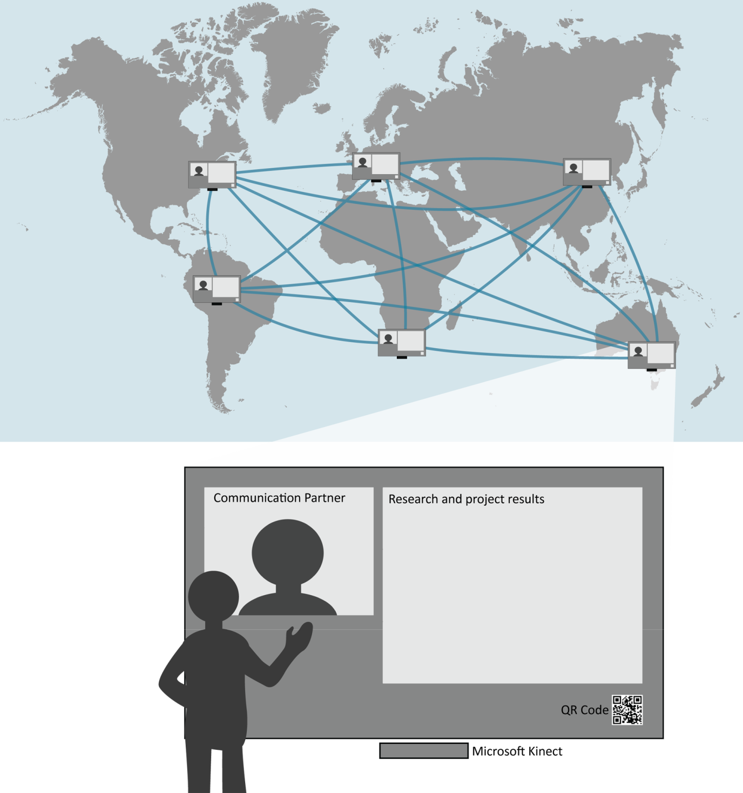

Figure 1 - Different universities are connected with the Kinasion system, which allows for collaboration across borders using the Microsoft Kinect Sensor

Our system tries to reach the following goals: Present project results and findings in a more accessible manner (aesthetically and interactively), foster productive discussion between interested parties and develop and push existing ideas further, rather than reinventing the wheel.

Numerous Kinasions will be set up at participating universities all over the world in publicly accessible spaces. Kinasion will be controllable by Kinect and will display research results, which draw interest to a variety of people, on large screens.

They will be able to use the Kinasion for the following purposes:

* Browse, filter and view different research and project results
* Contact the author(s) directly via video chat (Microsoft Lync and Windows Live)
* Discuss research and project results with other interested people in the world
* Bookmark research and project results for further investigation (using a smartphone like Windows Phone 7)

We plan to develop an application prototype to demonstrate the feasibility of our system. Initially, the research and project results will be provided by our local university, the University of Applied Science Rapperswil. Currently, bachelor and master students are required to create posters describing their thesis results. As a first step we will focus on these posters. In the future other types of media, such as videos or other interactive content, could be envisioned.

The Kinasion could also be used to represent universities at exhibitions and fares. This gives people from the private sector the opportunity to gain new insights about the projects developed at universities. This could lead to new collaborations between entrepreneurs and universities.

3. Video walls are not a new concept per se and have been used for various purposes. The introduction of Microsoft Kinect has opened the doors to NUI driven video walls for the general public (since it is comparatively cheap). There already have been projects which combine video walls and gesture control like “Visuo-Gestural Interaction with a video wall”[4] or “Xerox Interactive Digital Out-of-Home Campaign”[5]. Most recently, Microsoft Switzerland have also built and installed a Kinect driven video wall at their Swiss headquarters. Using Kinect to show and navigate through documents is not a new idea either (for example DocZoom and Kinect[6]). NUI concepts for video chats using Kinects have also already been established: Microsoft provides the Live Messenger on the Xbox with Kinect support for Live Gold members[7].

However, the symbiosis of these technologies to enable a collaborative research platform is new (to our best knowledge).

4. To develop this software, many tools and libraries are used. Since we are still in the exploration phase of our project we cannot list all of tools and libraries we might be using. We’ve tried to compile a list which should encompass most of them (they may change during the development of the project). However, we will document every tool and library used at the various competition rounds and only use research material for which we have obtained permission. The main components of our solution use Microsoft Windows 7, Microsoft Kinect SDK (to interact with the Kinect sensor), Microsoft Windows Azure (to provide data globally), Microsoft Live SDK (to connect people) and Microsoft Lync (for video conference calls). Depending on the progress of our prototype, we will consider open sourcing the application if all licenses allow it and it corresponds to the rules of this competition.

We expect to use the following tools and libraries:

* Tools
  + Microsoft Expression Blend
  + Microsoft Visual Studio 2010 Ultimate with PowerTools
  + JetBrains ReSharper
  + Subversion
* Libraries
  + Microsoft Kinect SDK
  + Microsoft Windows Azure
  + Microsoft Live SDK
  + Microsoft Lync
  + NuGet Package Manager
  + Apache log4net
  + Unity Container
  + Coding4Fun Kinect Toolkit
  + Kinect Toolbox

5. As specified above, our Kinasion system will interact with the Microsoft Kinect SDK and therefore use Kinect specific NUI features. We intend to focus on skeleton tracking for gesture detection, which will be the most important method for the interaction with the video wall. Our plan is to reuse gesture patterns introduced by Microsoft in their Xbox games.

**1. Browse, filter and view different research and project results with Kinect**

For the browsing mode, it is envisaged to implement gestures to flick left or right to navigate to the next item. This should already be implemented by the Kinect Toolkit (section 4.).

Another common gesture, which can be observed in current Microsoft Xbox games, is to move the hand over a button and keep the position for two to three seconds to confirm the selection.

**2. Contact the author(s) directly via video chat (Microsoft Lync and Windows Live) and discuss research and project results with other interested people in the world**

With the aid of Microsoft Lync it is possible to connect people via video conference. It is very likely that the video camera will be used for video conferencing. But it is also imaginable that the depth camera is used for that instead of the normal video to guarantee the anonymity of the people for the video conference. This will depend on usability tests.

**3. Bookmark research and project results for further investigation (using a smartphone like Windows Phone 7)**

To get more details about a specific item or to be able to contact its author, each item can contain a QR code, which can be photographed by a mobile phone. This QR code contains a link to the server where more information like contact information about the author is available. By the use of this code, the information can be stored on the mobile phone and be inspected later in detail.

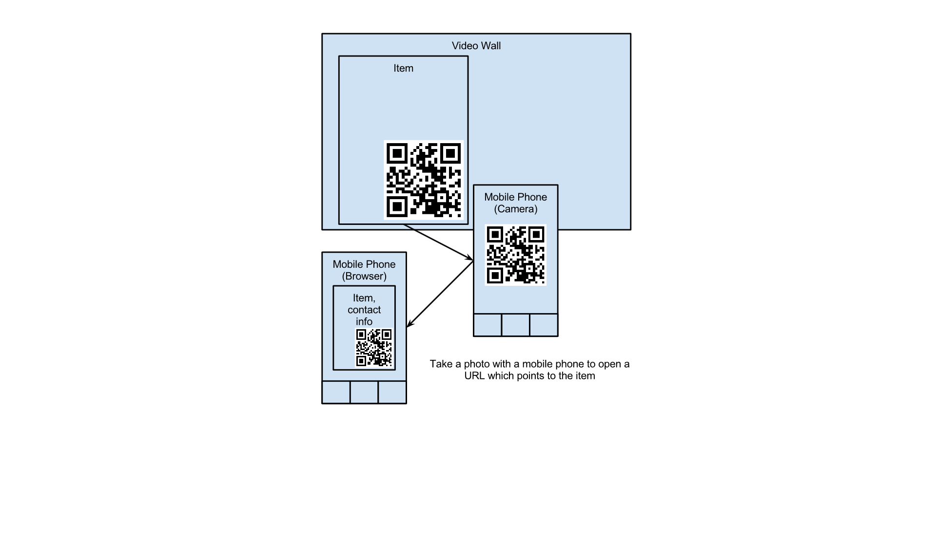

Figure 2 - Using a Windows Phone device to scan a QR code displayed on the video wall to gather further information about the displayed project

**Global availability and system architecture**

To make the data available globally we intend to use the Windows Azure cloud services. Through these services the Kinasions (which are geographically dispersed) are enabled to communicate with each other. New content can be made available around the world.

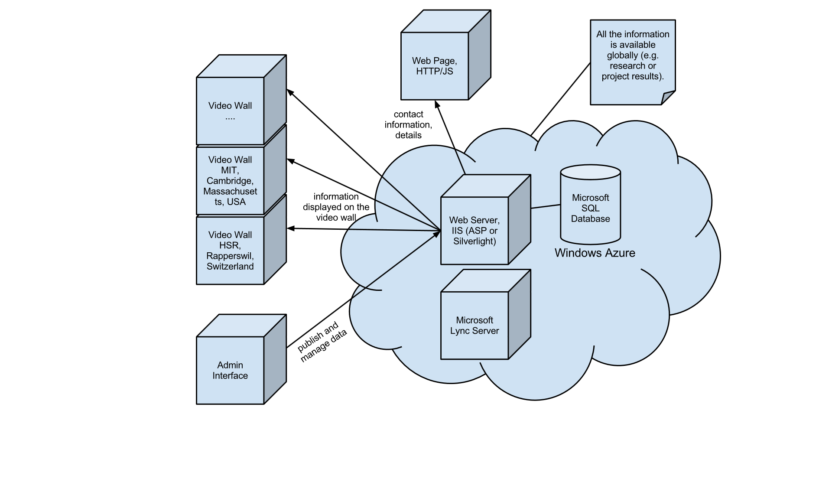

Figure 3 - Proposed System Architecture Kinasion

The subsequent figure shows how the system structure of the Kinasion application could look like:

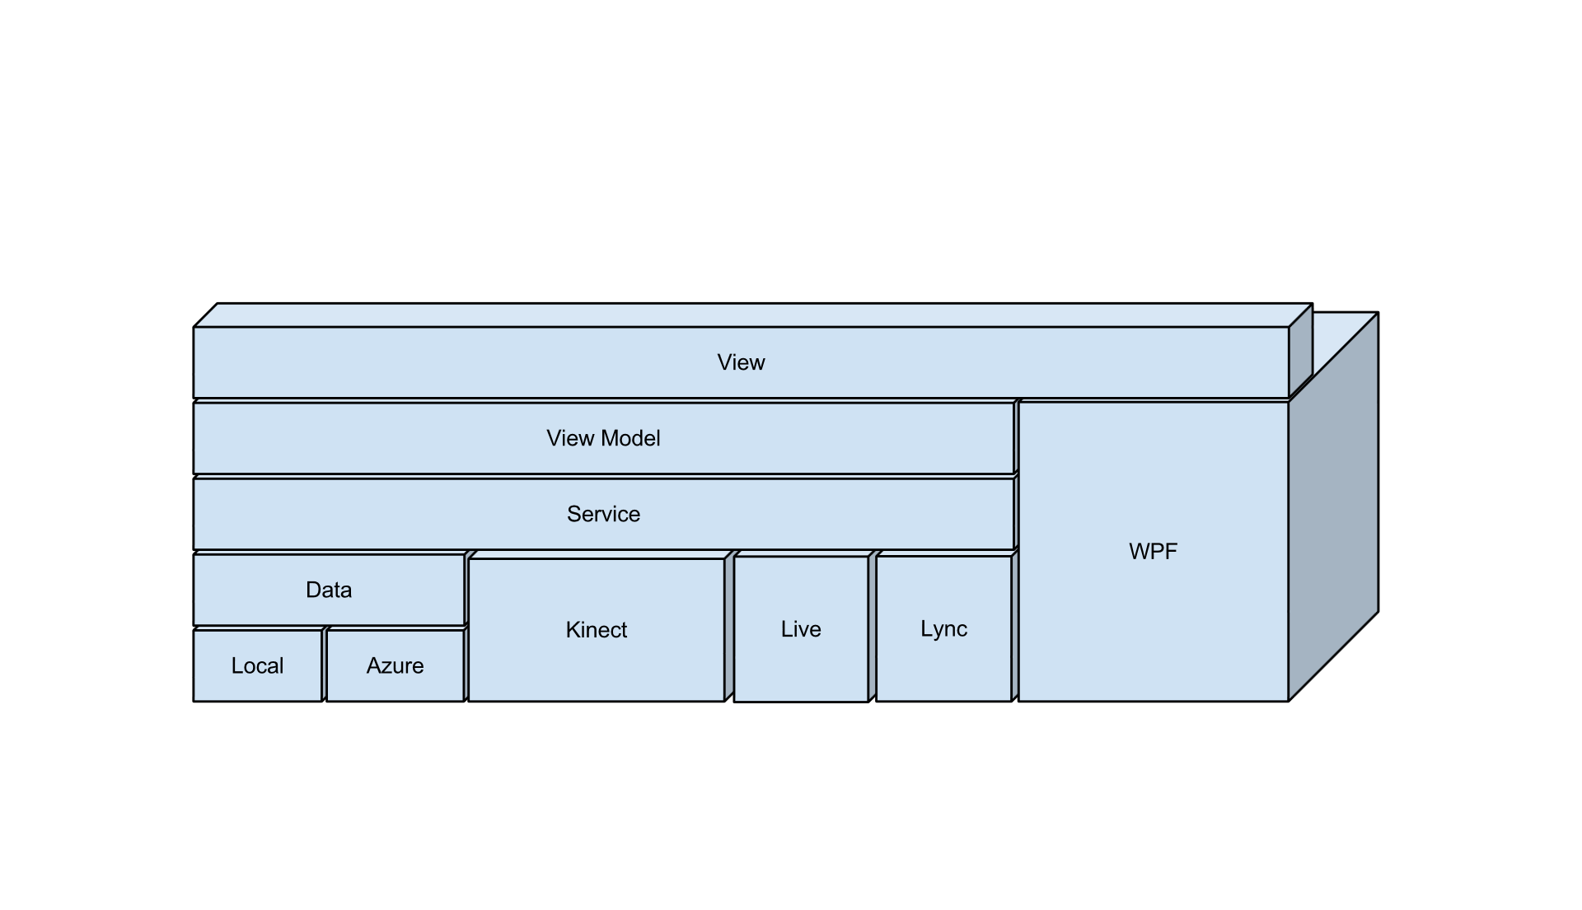

Figure 4 - Proposed layer diagram of Kinasion

6. **Interaction zones**

People use interpersonal distance to control their interactions with other people. The closer the distance, the more intimate are the interactions. Saul Greenberg[8] describes how this knowledge about the interpersonal distance can be used in relation to digital devices and how these can detect people and other devices which are in the same room. It is also of fundamental importance to accurately know where they are located. The article mentions the four interaction zones[9] defined by Vogel and Balakrishnan: ambient display, implicit interaction, subtle interaction and personal interaction. Depending on the interaction zone the person is located in, the digital display should react differently. This is described subsequently:

People standing or passing by out of reach of the Kinect (>8m) sensors are in the **ambient display zone**. General information is displayed on the screen to give the user an overview of the information or interactive features offered by the system.

Becoming aware of the Kinasion system, the user passes into the next zone (6-8m): the **implicit interaction zone**. The Kinect senors can recognize and encourage the player to come closer (4-6m) to interact with the system and hence entering the **proximate interaction zone**.

In the **subtle interaction zone** (1.5-4m) the user interacts directly with the system. To maintain his/her attention he/she needs to be entertained by information and interactive content. The user can browse and explicitly choose what to see from the repository and the system will offer detailed information about it.

The final zone (0.8-1.5m) is called **personal interaction zone**. To take a photo of a QR code of a research result, the user steps closer and thus enters this zone.

**Kinect UI patterns**

To show the user that he is in control of the application, an avatar will be displayed on the screen. The avatar mimes every movement of the player.

Since there are no loading periods for this application, there is no possibility to show any navigation instructions. This is why a digital mentor in the bottom left corner tells the users how to interact with the application. It indicates the different available gestures to navigate such as flicking left or right to proceed to the next item.

To ensure an intuitional and easy to use user interface the application will be developed by processing user centred design. The usability of the application will be periodically tested to assure the ease of operation of the application. This is achieved with usability tests.

7. We would highlight the easier exchange of information and the possibility to discuss research and project results, even if the conversational partners are thousands of miles apart, in a playful manner.

The following scenario describes the best way to show our system in a video:

Mary studies at the University in Rapperswil. She needs to find a project idea for her bachelor thesis. Since her university has a Kinasion system set up, she decides to try it. As soon as she walks up to the system, it recognizes her. Using gestures she browses the repository of research topics until she finds an interesting research project. If only she had a notepad with her to look up the project later. On the bottom right corner she recognizes a QR code which she tries to scan with her Windows Phone 7. Her action results in the phone showing more information about this particular project which she saves to her phone. Just as she wants to walk away the screen lights up, the research project’s author, Joe from Jamaica, has signed in into his Windows Live account. This gives Mary the opportunity to discuss the project with Joe through Microsoft Lync. Happy to have found her bachelor thesis project idea, Mary returns to the library.

1. http://www.un.org/millenniumgoals/, retrieved 5.3.2012
2. Level & Trends in Child Mortality, Report 2011, D. You, G. Jones, T. Wardlaw, United Nations Inter-agency Group for Child Mortality Estimation, New York, http://www.unicef.org/media/files/Child_Mortality_Report_2011_Final.pdf, retrieved 5.3.2012
3. http://foldit.com, retrieved 5.3.2012
4. http://gesture-lyon2005.ens-lyon.fr/IMG/pdf/InteractincBodies_GianniDalle.pdf, retrieved 6.3.2012
5. http://www.screenmediadaily.com/news-xerox-tronic-marriott-target-digital-signage-out-of-home-advertising-media-airports-001400770.shtml, retrieved 6.3.2012
6. http://www.youtube.com/watch?v=B76fmLwaB1s, retrieved 6.3.2012
7. http://support.xbox.com/de-CH/kinect/setup-and-playspace/video-kinect, retrieved 6.3.2012
8. Proxemic Interactions: The New Ubicomp?, Volume XVIII.1, January+February 2011, S. Greenberg, Association for Computing Machinery, 2011
9. Interactive public ambient displays: transitioning from implicit to explicit, public to personal, interaction with multiple users, D. Vogel and R. Balakrishnan, Proceedings of the 17th annual ACM symposium on User Interface Software and Technology. ACM, New York, 2004